Digital Delivery External API Service
Equipment Breakdown
Version 9.0

Table of Contents
1 Overview 3
2 Business Purpose 3
3 Architecture 3
3.1 Service Topology Diagram 4
4 Security 4
5 Digital Delivery Quote API 5
5.1 Request Message 5
5.2 Request Validation 9
5.3 Response Message 9
6 Digital Delivery Bind API 19
6.1 Request Message 19
6.2 Request Validation 25
6.3 Response Message 25
7 Exception Handling and Recovery 29
8 How to Test Using SOAP 33
8.1 Sample EB Request(s) 33
8.2 Sample CS Request(s) 33
8.3 Sample PL Request(s) 34
8.2 SOAP Tool Setup 34
9 How to Test Using Developer Portal 39
9.1 Instruction on using the UID in the request 39
10 Document Revision History 46

Overview
Hartford Steam Boiler (HSB) is constantly expanding its portfolio of system-to-system integration options via APIs hosted on Microsoft’s Azure Cloud.

Business Purpose
HSB reinsurance treaties are typically implemented and maintained in full by our clients. The client’s Quote, Issuance, and Policy Admin systems must be programmed to support the HSB products, and adopting changes to those products is the responsibility of the client. Clients may spend more than a year to plan and implement a new HSB product, and eventual changes to the product can present significant IT expense to adopt. This is particularly burdensome when new HSB products are evolving quickly to meet market demands. The purpose of the HSB Digital Delivery platform is to reduce the burden on client companies to deploy and maintain HSB products.
Equipment Breakdown insurance pays for financial loss incurred when equipment breaks down due to an accident or electronic circuitry impairment. It works a lot like property coverage, but covers the unique risks of equipment and technology. Equipment breakdown insurance covers equipment accidents from risks of loss such as power surges, short circuits, centrifugal force, boiler overheating or cracking, and mechanical breakdown.
- The Digital Delivery Quote API will respond with the client company’s filed product limits, rates, deductibles, eligibility rules and form numbers.
- The Digital Delivery Bind API will respond with the client company’s filed forms and declaration pages, complete with selected product options.

Architecture
HSB has built a secured cloud Application Program Interface (API) to provide information related to Digital Delivery.
API’s are available through Secure Cloud with various security options, see section 4 for information.

Service Topology Diagram

Security
Access to HSB’s API products begins by obtaining a subscription account, and then enable your API module for that account. An API account can be coordinated through HSB’s integration team:
HSBIntegrationTeam@hsb.com
HSB utilizes Microsoft Azure’s API Management tool for exposing internal APIs to external Client Companies by applying two security/authentications to the HSB API (internal) and access the API from the Internet (external):
Security Level 1: URL and HSB provided Subscription Key,
Security Level 2: URL and HSB provided Subscription Key plus OAuth2 Token/certificate.

Digital Delivery Quote API
This service allows an external system to create Quote.

Request Message
Type | SubType | Field | Required for API | Required for Reporting | Description
SignonRq | SignonTransport/CustId | SPName | Y |  | Domain name of carrier
SignonRq | SignonTransport/CustId | CustLoginId | Y | Y | Identity of carrier - parent company
SignonRq |  | ClientDt | Y |  | Date and time stamp from carrier's system
SignonRq |  | CustLangPref | Y |  | Preferred language of requester
SignonRq | ClientApp | Org | Y |  | Name of requesting company
SignonRq | ClientApp | Name | Y |  | Insurer application name where request is originating from - Agent, Consumer or Underwriter
SignonRq | ClientApp | Version | Y |  | Version of insurer application where request is originating from
InsuranceSvcRq | ItemIdInfo/OtherIdentifier | UID | Y |  | Request Identifier - unique for each transaction
InsuranceSvcRq | PolicyRq | BusinessPurposeTypeCd | Y | Y | This field identifies the type of transaction(NBQ,RWQ,PCQ,REW)
InsuranceSvcRq | PolicyRq /ItemIdInfo/OtherIdentifier | UID | Y |  | Unique identifier of the request. It should be returned along with response to correlate.
InsuranceSvcRq | PolicyRq | TransactionRequestDt | Y | Y | DateTime that carrier submits request to HSB
InsuranceSvcRq | PolicyRq | TransactionEffectiveDt |  | Y | DateTime on which transaction takes effect  Mandatory in case of PCQ transaction
InsuranceSvcRq | PolicyRq | ACORDStandardVersionCd | Y |  | ACORD Version Number. Current version is 280 and It will support less than 280.
InsuranceSvcRq | PolicyRq /Producer/ItemIdInfo | InsurerID |  |  | The agent ID an Insurer assigned to an individual Agent
InsuranceSvcRq | PolicyRq /Producer | ContractNumber |  | Y | Optional field for the agency/broker number or code assigned by the insurer
InsuranceSvcRq | PolicyRq /Producer | PlacingOffice |  | Optional | Optional field for identifying the branch Id or code for the agency assigned by the insurer
InsuranceSvcRq | PolicyRq /InsuredOrPrincipal | Name |  | Y | Name of Insured Company or Person
InsuranceSvcRq | PolicyRq/InsuredOrPrincipal /SupplementaryNameInfo | SupplementaryNameCd |  |  | Code indicating type of supplementary name(DBA)
InsuranceSvcRq | PolicyRq/InsuredOrPrincipal /SupplementaryNameInfo | SupplementaryName |  |  | Supplementary name for the Insured
InsuranceSvcRq | PolicyRq/InsuredOrPrincipal/Addr | Addr1 |  | Y | Mailing address of the Insured
InsuranceSvcRq | PolicyRq/InsuredOrPrincipal/Addr | City |  | Y | Mailing City of the insured
InsuranceSvcRq | PolicyRq/InsuredOrPrincipal/Addr | StateProvCd |  | Y | Mailing State of the insured
InsuranceSvcRq | PolicyRq/InsuredOrPrincipal/Addr | PostalCode |  | Y | Mailing postal code of insured
InsuranceSvcRq | PolicyRq/InsuredOrPrincipal | SICCd | Can be optional/Mandatory Either may be configured based on carrier preference |  | Primary risk classification of insured.
InsuranceSvcRq | PolicyRq/InsuredOrPrincipal | NAICSCd |  |  | Primary risk classification of insured.
InsuranceSvcRq | PolicyRq/InsuredOrPrincipal | GeneralLiabilityCd |  |  | Primary risk classification of insured.
InsuranceSvcRq | PolicyRq/Policy | Policy Number |  | Y | Policy number will be optional for New business and rewrite transaction and it will be mandatory for policy change and renewal transaction.
InsuranceSvcRq | PolicyRq/Policy | LOBCd | Y | Y | Line of business – will use PROP when Commercial Property Line of business; BOP when Business Owners Policy; COP when Commercial Output Program
InsuranceSvcRq | PolicyRq/Policy | NAICCd | Y |  | NAIC code of the writing company
InsuranceSvcRq | PolicyRq/Policy | ControllingStateProvCd | Y |  | Controlling state of the underlying policy to which HSB products may be attached.
InsuranceSvcRq | PolicyRq/Policy/ContractTerm | EffectiveDt | Y |  | Effective date of underlying policy to which HSB products will be attached
InsuranceSvcRq | PolicyRq/Policy/ContractTerm | ExpirationDt | Y | Y | Expiration date of underlying policy to which HSB products will be attached
InsuranceSvcRq | PolicyRq/Policy/OtherOrPriorPolicy | PolicyCd |  |  | Code used to identify the type of policy being defined. In this case it is ‘Prior’
InsuranceSvcRq | PolicyRq/Policy/OtherOrPriorPolicy | PolicyNumber |  | Y | Prior Policy Number for Rewrite transactions
InsuranceSvcRq | PolicyRq/Policy/QuoteInfo | CompanysQuoteNumber |  |  | Carrier's quote number
InsuranceSvcRq | PolicyRq/Policy | RenewalStatusCd |  |  | RenewalStatusCd is to identify the policy type for PCQ transaction whether NBQ or RWQ.  For new business will be blank, for renewal value equal to “Renewed”
InsuranceSvcRq | PolicyRq/Policy/Coverage | CoverageCd | Optional for NBQ, RWQ, PCQ and mandatory for REW | Y  for REW, XLC | Code for the coverage provided(EQPBK)
InsuranceSvcRq | PolicyRq/Policy/Coverage | EffectiveDt |  | Y  PCQ and RWQ | Effective date of underlying policy to which HSB products will be attached.  Effective date will be mandatory in only PCQ transaction.
InsuranceSvcRq | PolicyRq/Policy/PolicyExt | ApprovalNumber |  |  | Provided by HSB during manual workflow- Format : ANEBXXXXXX
InsuranceSvcRq | PolicyRq/Location | id | Y | Y | Location Identifier
InsuranceSvcRq | PolicyRq/Location/Addr | Addr1 |  | Y | Location Address
InsuranceSvcRq | PolicyRq/Location/Addr | City |  | Y | Location City
InsuranceSvcRq | PolicyRq/Location/Addr | StateProvCd |  | Y | Location State
InsuranceSvcRq | PolicyRq/Location/Addr | PostalCode |  | Y | Location Postal Code
InsuranceSvcRq | PolicyRq/Location | LocationName |  | Y | Descriptive name of the locaiton
InsuranceSvcRq | PolicyRq/[CommlPropertyLineBusiness or BOPLineBusiness]/PropertyInfo/ CommlPropertyInfo | LocationRef | Y |  | 1 Location Reference  2 use CommlPropertyLineBusiness when Policy/LOBCd = PROP/COP  3 use BOPLineBusiness when Policy/LOBCd = BOP
InsuranceSvcRq | PolicyRq/[CommlPropertyLineBusiness or BOPLineBusiness]/PropertyInfo/ CommlPropertyInfo | ClassCd | Y | Y | (BOP,COP or PROP) code  ClassCd will not be mandatory when approval number is given.
InsuranceSvcRq | PolicyRq/[CommlPropertyLineBusiness or BOPLineBusiness]/PropertyInfo/ CommlPropertyInfo | ClassCdDesc |  |  | BOP,COP or PROP class code description
InsuranceSvcRq | PolicyRq/[CommlPropertyLineBusiness or BOPLineBusiness]/PropertyInfo/ CommlPropertyInfo/Coverage/Limit | FormatInteger |  |  | The Total Insured Value (TIV) Limit for the given location/building. TIV = Building Value + Contents value + Business Income value  This will be configurable to mandatory or not based on the carrier. As the rating methodology can change based on carriers.
InsuranceSvcRq | PolicyRq/[CommlPropertyLineBusiness or BOPLineBusiness]/PropertyInfo/ CommlPropertyInfo/Coverage/Limit | ValuationCd |  |  | Identifies the valuation type or valuation requested (Total Insured Value)
InsuranceSvcRq | PolicyRq/[CommlPropertyLineBusiness or BOPLineBusiness]/ PropertyInfo/PropertyInfoExt /CurrentTermAmt | Amt |  | Y | Total Property Premium - This will be configurable to mandatory or not based on the carrier. As the rating methodology can change based on carriers.
InsuranceSvcRq | PolicyRq/[CommlPropertyLineBusiness or BOPLineBusiness]/ PropertyInfo/PropertyInfoExt /Limit | FormatInteger |  |  | Sum of location level TIVs
InsuranceSvcRq | PolicyRq/[CommlPropertyLineBusiness or BOPLineBusiness]/ PropertyInfo/PropertyInfoExt /Limit | LimitAppliesToCd |  |  | Code for the Limit applied
InsuranceSvcRq | PolicyRq/[CommlPropertyLineBusiness or BOPLineBusiness]/ PropertyInfo/PropertyInfoExt/ Deductible | FormatInteger | Y | Y | This is policy level deductible.
InsuranceSvcRq | PolicyRq/[CommlPropertyLineBusiness or BOPLineBusiness]/ PropertyInfo/PropertyInfoExt/ Deductible | DeductibleTypeCd | Y |  | A code list that identifies the type of deductible like  OC – Per occurrence  OT – Other  PC - Percent
InsuranceSvcRq | PolicyRq/[CommlPropertyLineBusiness or BOPLineBusiness]/ PropertyInfo/PropertyInfoExt/ Deductible | DeductibleAppliesToCd | Y |  | A code that indicates when (under what circumstances) a deductible is to be paid on a loss.  Example –  PropertyDeductible  propertyDamageDeductible

Request Validation
Requests that do not contain elements marked as “Y” will generate a failure response from the API. See Section 7 for details regarding Exception Handling and Recovery.

Response Message
Type | Sub Type | Field | Description
SignonRs | Status | StatusCd | Status of transaction
SignonRs | Status | StatusDesc | Description of transaction status
SignonRs | CustId | SPName | Domain name of carrier
SignonRs | CustId | CustLoginId | Identity of carrier - parent company
SignonRs |  | ClientDt | Date and time stamp from carrier's system
SignonRs |  | CustLangPref | Preferred language of requester
SignonRs | ClientApp | Org | Name of requesting company
SignonRs | ClientApp | Name | Application being requested
SignonRs | ClientApp | Version | Application Version
SignonRs |  | ServerDt | Date and time stamp from HSB's system
SignonRs |  | Language | Language of the HSB response
InsuranceSvcRs | ItemIdInfo/OtherIdentifier | UID | Response Identifier - unique for each transaction
InsuranceSvcRs | PolicyRs | BusinessPurposeTypeCd | This field identifies the type of transaction
InsuranceSvcRs | PolicyRs / ItemIdInfo /OtherIdentifier | UID | Quote Identifier - echoed back from request so transaction response can be aligned to the request
InsuranceSvcRs | PolicyRs | TransactionResponseDt | Date that HSB Responds to the carrier's request
InsuranceSvcRs | PolicyRs | TransactionEffectiveDt | Date on which the transaction takes effect
InsuranceSvcRs | PolicyRs/ MsgStatus | MsgStatusCd | HSB sends in response, valid values - Success, Error, SuccessWithInfo
InsuranceSvcRs | PolicyRs/ MsgStatus | MsgErrorCd | HSB response when MsgStatusCd is ‘Error’. valid values are DataError, GeneralFailure, NotAvailable
InsuranceSvcRs | PolicyRs/MsgStatus/ ExtendedStatus | ExtendedStatusCd | HSB sends in response when an error or informational message is to be conveyed to the insurer. Applies when MsgStatusCd = ‘SuccessWithInfo’ or (‘Error’ and MsgErrorCd = ‘DataError’). Valid values = ‘DataMissing’, ‘DataInvalid’, ‘DataNotFound’.
InsuranceSvcRs | PolicyRs/MsgStatus/ ExtendedStatus | ExtendedStatusDesc | HSB sends in response when an error or informational message is to be conveyed to the insurer. Applies when MsgStatusCd = ‘SuccessWithInfo’ or (‘Error’ and MsgErrorCd = ‘DataError’). Valid values = ‘DataMissing’, ‘DataInvalid’, ‘DataNotFound’.
InsuranceSvcRs | PolicyRs | ACORDStandardVersionCd | ACORD Version Number
InsuranceSvcRs | PolicyRs/ Producer/ ItemIdInfo | InsurerID | This agent ID an Insurer assigned to an individual Agent
InsuranceSvcRs | PolicyRs/ Producer | ContractNumber | The agency/broker number or code assigned by the insurer
InsuranceSvcRs | PolicyRs/ Producer | PlacingOffice | The branch Id or code for the agency assigned by the insurer
InsuranceSvcRs | PolicyRs/ InsuredOrPrincipal | Name | Name of Insured Company or Person
InsuranceSvcRs | PolicyRs/InsuredOrPrincipal/SupplementaryNameInfo | SupplementaryNameCd | Code indicating type of supplementary name(DBA)
InsuranceSvcRs | PolicyRs/InsuredOrPrincipal/SupplementaryNameInfo | SupplementaryName | Supplementary name for the Insured
InsuranceSvcRs | PolicyRs/InsuredOrPrincipal/ Addr | Addr1 | Mailing address of the Insured
InsuranceSvcRs | PolicyRs/InsuredOrPrincipal/ Addr | City | Mailing City of the insured
InsuranceSvcRs | PolicyRs/InsuredOrPrincipal/ Addr | StateProvCd | Mailing State of the insured
InsuranceSvcRs | PolicyRs/InsuredOrPrincipal/ Addr | PostalCode | Mailing postal code of insured
InsuranceSvcRs | PolicyRs/ InsuredOrPrincipal | SICCd | Primary risk classification of insured.
InsuranceSvcRs | PolicyRs/ InsuredOrPrincipal | NAICSCd | Primary risk classification of insured.
InsuranceSvcRs | PolicyRs/ InsuredOrPrincipal | GeneralLiabilityCd | Primary risk classification of insured.
InsuranceSvcRs | PolicyRs /Policy | Policy Number | Policy number will be optional for New business and rewrite transaction and it will be mandatory for policy change and renewal transaction.
InsuranceSvcRs | PolicyRs /Policy | LOBCd | Line of business – will use PROP when Commercial Property Line of business; BOP when Business Owners Policy; COP when Commercial Output Program
InsuranceSvcRs | PolicyRs /Policy | NAICCd | NAIC code of the writing company
InsuranceSvcRs | PolicyRs /Policy | ControllingStateProvCd | Controlling state of the underlying policy to which HSB products may be attached.
InsuranceSvcRs | PolicyRs/Policy /ContractTerm | EffectiveDt | Effective date of underlying policy to which HSB products will be attached
InsuranceSvcRs | PolicyRs/Policy /ContractTerm | ExpirationDt | Expiration date of underlying policy to which HSB products will be attached
InsuranceSvcRs | PolicyRs/Policy/ OtherOrPriorPolicy | PolicyCd | Code used to identify the type of policy being defined. In this case it is ‘Prior’
InsuranceSvcRs | PolicyRs/Policy/ OtherOrPriorPolicy | PolicyNumber | Prior Policy Number for Rewrite transactions
InsuranceSvcRs | PolicyRs/Policy/ QuoteInfo | CompanysQuoteNumber | Carrier's quote number
InsuranceSvcRs | PolicyRs/Policy | RenewalStatusCd | RenewalStatusCd is to identify the policy type for PCQ transaction whether NBS or RWL.  For new business will be blank, for renewal value equal to “Renewed”
InsuranceSvcRs | PolicyRs/Policy/ Coverage | CoverageCd | ISO Coverage Code for HSB coverage
InsuranceSvcRs | PolicyRs/Policy/Coverage | EffectiveDt | Effective date of underlying policy to which HSB products will be attached
InsuranceSvcRs | PolicyRs/Policy/CoverageAvailable/ ItemIdInfo | VersionNumber | Informs the carrier the version of the Product HSB is using within this request for rate/quote. The version number will align with the version that carrier has adopted – based on rate/rule filings.
InsuranceSvcRs | PolicyRs/Policy/ /CoverageAvailable | CoverageCd | Code of the HSB coverage provided
InsuranceSvcRs | PolicyRs/Policy/ /CoverageAvailable | CoverageDesc | Description of available coverage
InsuranceSvcRs | PolicyRs/Policy/ /CoverageAvailable | CoverageName | Name of the coverage
InsuranceSvcRs | PolicyRs/Policy/CoverageAvailable/Deductible | FormatInteger | Deductible for the available coverage
InsuranceSvcRs | PolicyRs/Policy/CoverageAvailable/Deductible | DeductibleTypeCd | A code list that identifies the type of deductible like  OC – Per occurrence  OT – Other  PC - Percent
InsuranceSvcRs | PolicyRs/Policy/CoverageAvailable/Deductible | DeductibleAppliesToCd | A code that indicates when (under what circumstances) a deductible is to be paid on a loss.  Example –  PropertyDeductible  propertyDamageDeductible
InsuranceSvcRs | PolicyRs/Policy/CoverageAvailable/Deductible/DeductibleExt/Exception | id | 1 For Referral Flow  2 Optional exceptions to the policy level deductible, can be 1 – 5 occurrences
InsuranceSvcRs | PolicyRs/Policy/CoverageAvailable/Deductible/DeductibleExt/Exception | ExceptionName | 1 For Referral Flow  2 Free form exception descriptiopn entered by HSB U/W, max caharcters allowed is 100  Example –  Except Induction Furn. Trans. >5000 KVA  Except Medical Diagnostic Equipment
InsuranceSvcRs | PolicyRs/Policy/CoverageAvailable/Deductible/DeductibleExt/Exception | ExceptionValue | For Referral Flow, exception value to corresponding exception name.  Example –  $6.00 per KVA, $25,000 Minimum  5 Times ADV
InsuranceSvcRs | PolicyRs/Policy/CoverageAvailable/Option | OptionData | 1 For Referral Flow  2 Value which U/W enters for describing any other exception or notes
InsuranceSvcRs | PolicyRs/Policy/CoverageAvailable/Option | OptionName | 1 For Referral Flow
InsuranceSvcRs | PolicyRs/Policy/CoverageAvailable/CurrentTermAmt | Amt | Rate of premium, for this product it will be percentage of policy premium
InsuranceSvcRs | PolicyRs/Policy/CoverageAvailable/Form | FormNumber | Form Number to be part of response, will driven based on the state
InsuranceSvcRs | PolicyRs/Policy/CoverageAvailable/Form | FormName | Form name
InsuranceSvcRs | PolicyRs/Policy/CoverageAvailable/Form | EditionDt | The date usually found on the preprinted form, which indicates the date the form became effective.
InsuranceSvcRs | PolicyRs/Policy/CoverageAvailable/CoverageSupplement | CoverageSubCd | Coverage code of supplemental coverage available with this product
InsuranceSvcRs | PolicyRs/Policy/CoverageAvailable/CoverageSupplement | CoverageDesc | Description of supplemental coverage
InsuranceSvcRs | PolicyRs/Policy/CoverageAvailable/CoverageSupplement | CoverageName | Name of supplemental coverage
InsuranceSvcRs | PolicyRs/Policy/CoverageAvailable/CoverageSupplement | SubjectOptionsTitleCd | This code whether the coverage is a first party or third party coverage. Valid values - FUL1P or FUL3P
InsuranceSvcRs | PolicyRs/Policy/CoverageAvailable/CoverageSupplement/ CoverageSupplementExt/Limit | FormatInteger | Limit for the available coverage
InsuranceSvcRs | PolicyRs/Policy/CoverageAvailable/CoverageSupplement/ CoverageSupplementExt/Limit | LimitAppliesToCd | Code for the Limit applied
InsuranceSvcRs | PolicyRs/Policy/CoverageAvailable/CoverageSupplement/Option | OptionTypeCd | A code identifying the Type of Option being applied.  Example - NumV1
InsuranceSvcRs | PolicyRs/Policy/CoverageAvailable/CoverageSupplement/Option | OptionName | The name of the option, generally applicable to a coverage, like a subcoverge.  Example for coverage “Spoilage and Consequential Damage” can have a sub coverage “Refrigerant Contamination” as option name
InsuranceSvcRs | PolicyRs/Policy/CoverageAvailable/CoverageSupplement/ CoverageSupplementExt/Option | OptionCd | Identifying code of included supplemental coverage option
InsuranceSvcRs | PolicyRs/Policy/CoverageAvailable/CoverageSupplement/ CoverageSupplementExt/Option | OptionData | Description of included supplemental coverage
InsuranceSvcRs | PolicyRs/Policy/CoverageAvailable/CoverageSupplement/ CoverageSupplementExt/Option | OptionName | Name of included supplemental coverage
InsuranceSvcRs | PolicyRs/Policy/CoverageAvailable/CoverageSupplement/ CoverageSupplementExt/Option/ OptionExt/ Limit | FormatText | Limit for the available coverage
InsuranceSvcRs | PolicyRs/Policy/CoverageAvailable/CoverageSupplement/ CoverageSupplementExt/Option/ OptionExt/ Limit | FormatInteger | Limit for the available coverage
InsuranceSvcRs | PolicyRs/Policy/CoverageAvailable/CoverageSupplement/ CoverageSupplementExt/Option/ OptionExt/ Limit | LimitAppliesToCd | Code for the Limit applied
InsuranceSvcRs | PolicyRs/Policy/CoverageAvailable/CoverageSupplement/ CoverageSupplementExt/Option | OptionTypeCd | A code identifying the Type of Option being applied.  Example - NumV1
InsuranceSvcRs | PolicyRs/Policy/CoverageAvailable/CoverageSupplement/ CoverageSupplementExt/Option | OptionValue | Provides the quantity when the OptionTypeCd represents a numeric value
InsuranceSvcRs | PolicyRs/Policy/CoverageAvailable/CoverageSupplement/ CoverageSupplementExt/Option | OptionValueDesc | Used to provide additional information about data being collected in OptionValue
InsuranceSvcRs | PolicyRs/Policy/CoverageAvailable/CoverageSupplement/ CoverageSupplementExt | OptionDesc | Used to provide additional information about data being collected in OptionValue
InsuranceSvcRs | PolicyRs/Policy/CoverageAvailable/CoverageSupplement/ CoverageSupplementExt/Limit | FormatText | Limit for the available coverage
InsuranceSvcRs | PolicyRs/Policy/CoverageAvailable/CoverageSupplement/ CoverageSupplementExt/ Deductible | FormatInteger | Deductible applied at the coverage level
InsuranceSvcRs | PolicyRs/Policy/CoverageAvailable/CoverageSupplement/ CoverageSupplementExt/ Deductible | DeductibleTypeCd | A code list that identifies the type of deductible like  OC – Per occurrence  OT – Other  PC - Percent
InsuranceSvcRs | PolicyRs/Policy/CoverageAvailable/CoverageSupplement/ CoverageSupplementExt/Option | OptionCd | A code that indicates when (under what circumstances) a deductible is to be paid on a loss.  Example –  PropertyDeductible
InsuranceSvcRs | PolicyRs/Policy/CoverageAvailable/CoverageSupplement/ CoverageSupplementExt/Option | OptionName | Name of included supplemental coverage
InsuranceSvcRs | PolicyRs/Policy/CoverageAvailable/CoverageSupplement/ CoverageSupplementExt/Option/ OptionExt/ Limit | FormatInteger | Limit for the available coverage
InsuranceSvcRs | PolicyRs/Policy/CoverageAvailable/CoverageSupplement/ CoverageSupplementExt/Deductible/DeductibleExt/Exception | id | 1 For Referral Flow  2 Free form exception descriptiopn entered by HSB U/W, max caharcters allowed is 100  Example –  Except Induction Furn. Trans. >5000 KVA  Except Medical Diagnostic Equipment
InsuranceSvcRs | PolicyRs/Policy/CoverageAvailable/CoverageSupplement/ CoverageSupplementExt/Deductible/DeductibleExt/Exception | ExceptionName | For Referral Flow, exception value to corresponding exception name.  Example –  $6.00 per KVA, $25,000 Minimum  5 Times ADV
InsuranceSvcRs | PolicyRs/Policy/CoverageAvailable/CoverageSupplement/ CoverageSupplementExt/Deductible/DeductibleExt/Exception | ExceptionValue | 1 For Referral Flow  2 Free form exception descriptiopn entered by HSB U/W, max caharcters allowed is 100  Example –  Except Induction Furn. Trans. >5000 KVA  Except Medical Diagnostic Equipment
InsuranceSvcRs | PolicyRs/Policy/CoverageAvailable/CoverageSupplement/QuestionAnswer | QuestionCd | Code identifying eligibility requirement
InsuranceSvcRs | PolicyRs/Policy/CoverageAvailable/CoverageSupplement/QuestionAnswer | AnswerTypeCd | Acceptable code for the answer. Y/N radio button
InsuranceSvcRs | PolicyRs/Policy/CoverageAvailable/CoverageSupplement/ QuestionAnswer/AnswerChoice | AnswerChoiceId | Id of the answer Answer choice
InsuranceSvcRs | PolicyRs/Policy/CoverageAvailable/CoverageSupplement/ QuestionAnswer/AnswerChoice | AnswerChoiceText | Text for the Answer
InsuranceSvcRs | PolicyRs/Policy/CoverageAvailable/CoverageSupplement/QuestionAnswer | QuestionText | Text associated with the eligibility requirement
InsuranceSvcRs | PolicyRs/Policy/CoverageAvailable/CoverageSupplement/ QuestionAnswer/QuestionAnswerExt | AcceptabilityAnswer | The answer accepted for the eligibility question to approve the request.
InsuranceSvcRs | PolicyRs/Policy/CoverageAvailable/CoverageSupplement/CoverageSupplementExt | CoverageSupplementAppliesToCd | To reflect whether this is eligibility question code or any other reason code
InsuranceSvcRs | PolicyRs/Policy/CoverageAvailable | CompanyProductCd | Code for the product offered by HSB
InsuranceSvcRs | PolicyRs/Policy/PolicyExt | ApprovalNumber | Provided by HSB during manual workflow - Format : ANEBXXXXXX
InsuranceSvcRs | PolicyRs/Location | id | Location Identifier
InsuranceSvcRs | PolicyRs/Location/Addr | Addr1 | Location Address
InsuranceSvcRs | PolicyRs/Location/Addr | City | Location City
InsuranceSvcRs | PolicyRs/Location/Addr | StateProvCd | Location State
InsuranceSvcRs | PolicyRs/Location/Addr | PostalCode | Location Postal Code
InsuranceSvcRs | PolicyRs/Location | LocationName | Descriptive name of the locaiton
InsuranceSvcRs | PolicyRs/[CommlPropertyLineBusiness or BOPLineBusiness]/PropertyInfo/CommlPropertyInfo | LocationRef | Location Identifier referencing the actual location address to its class code
InsuranceSvcRs | PolicyRs/[CommlPropertyLineBusiness or BOPLineBusiness]/PropertyInfo/CommlPropertyInfo | ClassCd | BOP,COP or PROP class code
InsuranceSvcRs | PolicyRs/[CommlPropertyLineBusiness or BOPLineBusiness]/PropertyInfo/CommlPropertyInfo | ClassCdDesc | BOP,COP or PROP class code description
InsuranceSvcRs | PolicyRs/[CommlPropertyLineBusiness or BOPLineBusiness]/PropertyInfo/CommlPropertyInfo/Coverage/Limit | FormatInteger | The Total Insured Value (TIV) Limit for the given location/building. TIV = Building Value + Contents value + Business Income value
InsuranceSvcRs | PolicyRs/[CommlPropertyLineBusiness or BOPLineBusiness]/PropertyInfo/ CommlPropertyInfo/Coverage/Limit | ValuationCd | Identifies the valuation type or valuation requested (Total Insured Value)
InsuranceSvcRs | PolicyRs/[CommlPropertyLineBusiness or BOPLineBusiness]/PropertyInfo/PropertyInfoExt/CurrentTermAmt | Amt | Total Property Premium - This will be configurable to mandatory or not based on the carrier. As the rating methodology can change based on carriers.
InsuranceSvcRs | PolicyRs/[CommlPropertyLineBusiness or BOPLineBusiness]/PropertyInfo/PropertyInfoExt/Limit | FormatInteger | Sum of locaion level TIVs
InsuranceSvcRs | PolicyRs/[CommlPropertyLineBusiness or BOPLineBusiness]/PropertyInfo/PropertyInfoExt/Limit | LimitAppliesToCd | Code for the Limit applied
InsuranceSvcRs | PolicyRs/[CommlPropertyLineBusiness or BOPLineBusiness]/PropertyInfo/PropertyInfoExt/Deductible | FormatInteger | Deductible value at policy level
InsuranceSvcRs | PolicyRs/[CommlPropertyLineBusiness or BOPLineBusiness]/PropertyInfo/PropertyInfoExt/Deductible | DeductibleTypeCd | A code list that identifies the type of deductible like  OC – Per occurrence  OT – Other  PC - Percent
InsuranceSvcRs | PolicyRs/[CommlPropertyLineBusiness or BOPLineBusiness]/PropertyInfo/PropertyInfoExt/Deductible | DeductibleAppliesToCd | A code that indicates when (under what circumstances) a deductible is to be paid on a loss.  Example –  PropertyDeductible  propertyDamageDeductible

Digital Delivery Bind API
This service allows an external system to Bind Policy.

Request Message

Type |  |  | Sub Type | Field |  | Required for API | Required for Reporting | Desciption
SignonRq |  |  | SignonTransport/CustId | SPName |  | Y |  | Insurer internet domain
SignonRq |  |  | SignonTransport/CustId | CustLoginId |  | Y | Y | HSB provides to customer
SignonRq |  |  |  | ClientDt |  | Y |  | Date and time stamp from carrier's system
SignonRq |  |  |  | CustLangPref |  | Y |  | Preferred language of requester
SignonRq |  |  | ClientApp | Org |  | Y |  | Insurer name, as defined by insurer
SignonRq |  |  | ClientApp | Name |  | Y |  | Insurer application name where request is originating from - Agent, Consumer or Underwriter
SignonRq |  |  | ClientApp | Version |  | Y |  | Version of insurer application where request is originating from
InsuranceSvcRq |  |  | ItemIdInfo/OtherIdentifier | UID |  | Y |  | Request Identifier - unique for each transaction
InsuranceSvcRq |  |  | PolicyRq | BusinessPurposeTypeCd |  | Y | Y | NBS indicates it is New Business; use PCH for Policy Change / Endorsements; RWL for Renewal Quote request; REW for Rewrite; REI for Reinstatement;XLC for cancellation confirmation (note: REW is treated as a NBS for purposes of rating/quoting, but provide indication that it was for a rewrite)
InsuranceSvcRq |  |  | PolicyRq/ItemIdInfo/OtherIdentifier | UID |  | Y |  | Quote identifier - unique for each bind (if multiple PolicyRq, then this would be different for each)
InsuranceSvcRq |  |  | PolicyRq | TransactionRequestDt |  | Y | Y | DateTime that carrier submits request to HSB
InsuranceSvcRq |  |  | PolicyRq | TransactionEffectiveDt |  |  | Y | DateTime on which transaction takes effect.  Mandatory in case of PCH transaction
InsuranceSvcRq |  |  | PolicyRq | ACORDStandardVersionCd |  | Y |  | v2.8 of the ACORD standards is the first version that supports the data requirements of the response
InsuranceSvcRq |  |  | PolicyRq/Producer/ItemIdInfo | InsurerID |  |  |  | For requests that do not originate from agent facing online application, the InsurerId element can be left empty or a constant value such as ‘Consumer’ could be input if the request comes from a consumer facing online quoting application. A value such as ‘Underwriter’ could be input if the request comes from an Underwriter facing application.  2."A002123" : Example of an Agent ID an insurer has assigned to an individual agent
InsuranceSvcRq |  |  | PolicyRq/Producer | ContractNumber |  |  | Y | The agency/broker number or code assigned by the insurer
InsuranceSvcRq |  |  | PolicyRq/Producer | PlacingOffice |  |  | Optional | Identifying the branch Id or code for the agency assigned by the insurer
InsuranceSvcRq |  |  | PolicyRq/InsuredOrPrincipal | Name |  | Optional for cancellation (XLC)and mandatory for other transactions(NBS, REW, RWL,REI, PCH) | Y | Name of Insured Company or Person  1) May have additional InsuredOrPrincipal nodes to align with information HSB will eventually need to add to the Forms through the Bind API (not required for rating, but to be consistent and having the Insured info is an easy way to identify the transaction when just looking at the XML)
InsuranceSvcRq |  |  | PolicyRq/InsuredOrPrincipal/SupplementaryNameInfo | SupplementaryNameCd |  |  |  | Code indicating type of supplementary name(DBA)
InsuranceSvcRq |  |  | PolicyRq/InsuredOrPrincipal/SupplementaryNameInfo | SupplementaryName |  |  |  | Supplementary name for the Insured
InsuranceSvcRq |  |  | PolicyRq/InsuredOrPrincipal/Addr | Addr1 |  |  | Y | Mailing address of the Insured
InsuranceSvcRq |  |  | PolicyRq/InsuredOrPrincipal/Addr | City |  |  | Y | Mailing City of the insured
InsuranceSvcRq |  |  | PolicyRq/InsuredOrPrincipal/Addr | StateProvCd |  |  | Y | Mailing State of the insured
InsuranceSvcRq |  |  | PolicyRq/InsuredOrPrincipal/Addr | PostalCode |  |  | Y | Mailing postal code of insured
InsuranceSvcRq |  |  | PolicyRq/InsuredOrPrincipal | Name |  | Optional for cancellation (XLC)and mandatory for other transactions(NBS, REW, RWL, PCH) |  | Secondary Insured node, Name is the only field that will be captured to be printed on the schedule forms
InsuranceSvcRq |  |  | PolicyRq/Policy | Policy Number |  | Y | Y | Policy number
InsuranceSvcRq |  |  | PolicyRq/Policy | LOBCd |  | Y | Y | Line of business– use PROP/COP when Commercial Property Line of business; BOP when Business Owners Policy
InsuranceSvcRq |  |  | PolicyRq/Policy | NAICCd |  | Y |  | Insurer NAIC code
InsuranceSvcRq |  |  | PolicyRq/Policy | ControllingStateProvCd |  | Optional for cancellation (XLC)and mandatory for other transactions(NBS, REW, RWL, PCH) |  | Controlling state of the underlying policy to which HSB products may be attached.
InsuranceSvcRq |  |  | PolicyRq/Policy/ContractTerm | EffectiveDt |  | Optional for cancellation (XLC)and mandatory for other transactions(NBS, REW, REI, RWL, PCH) |  | Effective date of underlying policy to which HSB products will be attached
InsuranceSvcRq |  |  | PolicyRq/Policy/ContractTerm | ExpirationDt |  | Optional for cancellation (XLC)and mandatory for other transactions(NBS, REW,REI, RWL, PCH) | Y | Expiration date of underlying policy to which HSB products will be attached
InsuranceSvcRq |  |  | PolicyRq/Policy/OtherOrPriorPolicy | PolicyCd |  |  |  | This informs HSB of the prior policy number - to be used for REW transactions
InsuranceSvcRq |  |  | PolicyRq/Policy/OtherOrPriorPolicy | PolicyNumber |  |  | Y | This informs HSB of the prior policy number
InsuranceSvcRq |  |  | PolicyRq/Policy/QuoteInfo | CompanysQuoteNumber |  |  |  | Carrier's quote number
InsuranceSvcRq |  |  | PolicyRq/Policy | RenewalStatusCd |  |  |  | RenewalStatusCd is to identify the policy type for PCH transaction whether NBS or RWL.
InsuranceSvcRq |  |  | PolicyRq/Policy/Coverage/ItemIdInfo | VersionNumber |  | Y |  | This version number represents the schema where the actual request will reside and if needed to understand the product version then whole number part of the version number will be product version
InsuranceSvcRq |  |  | PolicyRq/Policy/Coverage | CoverageCd |  | Optional for NBS, RWL, PCH and mandatory for REW, XLC | Y  For REW, XLC | Code for the coverage provided(EQPBK)
InsuranceSvcRq |  |  | PolicyRq/Policy/Coverage/CurrentTermAmt | Amt |  | Y | Y | Prorated premium based on the Coverage Term - to be determined by carrier as HSB provides annual premium in Quote response; HSB may choose to audit the prorated amount. Gross Premium Amount.
InsuranceSvcRq |  |  | PolicyRq/Policy/Coverage | EffectiveDt |  | Optional for cancellation (XLC)and mandatory for other transactions(NBS, REW, RWL,REI, PCH) | Y | This is the coverage term effective date
InsuranceSvcRq |  |  | PolicyRq/Policy/Coverage | ExpirationDt |  | Optional for cancellation (XLC)and mandatory for other transactions(NBS, REW, RWL,REI PCH) |  | This should align with the ContractTerm ExpirationDt, as the coverage is offered in conjunction with the policy term
InsuranceSvcRq |  |  | PolicyRq/Policy/Coverage/CoverageSupplement/QuestionAnswer | QuestionCd |  |  |  | Backdate Question Code
InsuranceSvcRq |  |  | PolicyRq/Policy/Coverage/CoverageSupplement/QuestionAnswer/AnswerChoice | AnswerChoiceId |  |  |  | Answer for Reason selection for backdate
InsuranceSvcRq |  |  | PolicyRq/Policy/PolicyExt | ApprovalNumber |  |  |  | Provided by HSB during manual workflow (limits above $1M or web service unavailable); will be used to retrieve the approved limit/rate/etc as the carrier needs all of this information in their system prior to binding coverage
InsuranceSvcRq |  |  | PolicyRq/Location | id |  |  |  | Location Identifier
InsuranceSvcRq |  |  | PolicyRq/Location/Addr | Addr1 |  |  | Y | Location Address
InsuranceSvcRq |  |  | PolicyRq/Location/Addr | City |  |  | Y | Location City
InsuranceSvcRq |  |  | PolicyRq/Location/Addr | StateProvCd |  |  | Y | Location State
InsuranceSvcRq |  |  | PolicyRq/Location/Addr | PostalCode |  |  | Y | Location Postal Code
InsuranceSvcRq |  |  | PolicyRq/Location/Communications | Id |  |  | Y | Communications Identifier
InsuranceSvcRq |  |  | PolicyRq/Location/Communications | PhoneNumber |  |  | Y | will be used for Inforce data - Inspection Contact's phone number
InsuranceSvcRq |  |  | PolicyRq/Location/Communications | EmailAddr |  |  | Y | will be used for Inforce data - Inspection Contact's email
InsuranceSvcRq |  |  | PolicyRq/Location/Communications/CommunicationsExt | Name |  |  | Y | will be used for Inforce data - Inspection Contact's name
InsuranceSvcRq |  |  | PolicyRq/Location | LocationName |  |  | Y | Location Name
InsuranceSvcRq |  |  | PolicyRq/ BOPLineBusiness/ PropertyInfo/ CommlPropertyInfo | LocationRef |  |  |  | Reference to the location address, used to connect location address to other details, like Building value.
InsuranceSvcRq |  |  | PolicyRq/ BOPLineBusiness/ PropertyInfo/ CommlPropertyInfo/Coverage | CoverageCd |  |  |  | Using the coverage code node to notify which component of TIV value is requested. Like –  BLDG – for Building vale  BPP – contents value  BMBI – Business Income value
InsuranceSvcRq |  |  | PolicyRq/ BOPLineBusiness/ PropertyInfo/ CommlPropertyInfo/Coverage/Limit | FormatInteger |  |  | Y | Actual numerical Limit values –  BLDG – for Building vale  BPP – contents value  BMBI – Business Income value
InsuranceSvcRq |  |  | PolicyRq/ BOPLineBusiness/ PropertyInfo/ CommlPropertyInfo/Coverage/Limit | LimitAppliesToCd |  |  |  | Using to notify the limit is for Insured value- InsuredVal
InsuranceSvcRq |  |  | PolicyRq/ BOPLineBusiness/ PropertyInfo/ CommlPropertyInfo/PropertyInfoExt/CurrentTermAmt | Amt |  |  | Y | Total Property Premium for the rating as defined in the treaty
InsuranceSvcRq |  |  | PolicyRq/ BOPLineBusiness/ PropertyInfo/ CommlPropertyInfo/PropertyInfoExt/Limit | FormatInteger |  |  |  | Policy level TIV = policy Building value + policy Contents value + Policy Business Income value
InsuranceSvcRq |  |  | PolicyRq/ BOPLineBusiness/ PropertyInfo/ CommlPropertyInfo/PropertyInfoExt/Limit | LimitAppliesToCd |  |  |  | Limit code to state which Limit it is applied to
InsuranceSvcRq |  |  | PolicyRq/Extension | ReprintIndicator |  |  |  | The reprint indicator will provide a way to reprint the forms and send back again, this does not impact any of the business logic, it only represents if its a new Bind request or a reprint request- Values "Y" and "N"

Request Validation
Requests that do not contain elements marked as “Y” will generate a failure response from the API. See Section 7 for details regarding Exception Handling and Recovery.

Response Message

Type | Sub Type | Field | Desciption
SignonRs | Status | StatusCd | Status of transaction
SignonRs | Status | StatusDesc | Description of transaction status
SignonRs | CustId | SPName | Domain name of carrier
SignonRs | CustId | CustLoginId | Identity of carrier - parent company
SignonRs |  | ClientDt | Date and time stamp from carrier's system
SignonRs |  | CustLangPref | Preferred language of requester
SignonRs | ClientApp | Org | Name of requesting company
SignonRs | ClientApp | Name | Application being requested
SignonRs | ClientApp | Version | Application Version
SignonRs |  | ServerDt | Date and time stamp from HSB's system
SignonRs |  | Language | Language of the HSB response
InsuranceSvcRs | ItemIdInfo/OtherIdentifier | UID | Response Identifier - unique for each transaction
InsuranceSvcRs | PolicyRs | BusinessPurposeTypeCd | This field identifies the type of transaction
InsuranceSvcRs | PolicyRs/ItemIdInfo/OtherIdentifier | UID | echoed back from request so transaction response can be aligned to the request
InsuranceSvcRs | PolicyRs | TransactionResponseDt | Date that HSB Responds to the carrier's request
InsuranceSvcRs | PolicyRs | TransactionEffectiveDt | DateTime on which transaction takes effect
InsuranceSvcRs | PolicyRs/ MsgStatus | MsgStatusCd | possible values are: Success, Error, Rejected, SuccessWithInfo
InsuranceSvcRs | PolicyRs/ MsgStatus | MsgErrorCd | HSB response when MsgStatusCd is ‘Error’. valid values are DataError, GeneralFailure, NotAvailable
InsuranceSvcRs | PolicyRs/MsgStatus/ ExtendedStatus | ExtendedStatusCd | HSB sends in response when an error or informational message is to be conveyed to the insurer. Applies when MsgStatusCd = ‘SuccessWithInfo’ or (‘Error’ and MsgErrorCd = ‘DataError’). Valid values = ‘DataMissing’, ‘DataInvalid’, ‘DataNotFound’,'VerifyDataValue’.
InsuranceSvcRs | PolicyRs/MsgStatus/ ExtendedStatus | ExtendedStatusDesc | HSB sends in response when an error or informational message is to be conveyed to the insurer. Applies when MsgStatusCd = ‘SuccessWithInfo’ or (‘Error’ and MsgErrorCd = ‘DataError’). Valid values = ‘DataMissing’, ‘DataInvalid’, ‘DataNotFound’.
InsuranceSvcRs | PolicyRs | ACORDStandardVersionCd | ACORD Version Number
InsuranceSvcRs | PolicyRs/ Producer/ ItemIdInfo | InsuredID | This agent ID an Insurer assigned to an individual Agent
InsuranceSvcRs | PolicyRs/ Producer | ContractNumber | The agency/broker number or code assigned by the insurer
InsuranceSvcRs | PolicyRs/ Producer | PlacingOffice | Identifying the branch Id or code for the agency assigned by the insurer
InsuranceSvcRs | PolicyRs/ InsuredOrPrincipal | Name | Name of Insured Company or Person
InsuranceSvcRs | PolicyRs/InsuredOrPrincipal/ SupplementaryNameInfo | SupplementaryNameCd | Code indicating type of supplementary name(DBA)
InsuranceSvcRs | PolicyRs/InsuredOrPrincipal/ SupplementaryNameInfo | SupplementaryName | Supplementary name for the Insured
InsuranceSvcRs | PolicyRs/InsuredOrPrincipal/Addr | Addr1 | Mailing address of the Insured
InsuranceSvcRs | PolicyRs/InsuredOrPrincipal/Addr | City | Mailing City of the insured
InsuranceSvcRs | PolicyRs/InsuredOrPrincipal/Addr | StateProvCd | Mailing State of the insured
InsuranceSvcRs | PolicyRs/InsuredOrPrincipal/Addr | PostalCode | Mailing postal code of insured
InsuranceSvcRs | PolicyRs /Policy | PolicyNumber | Policy number
InsuranceSvcRs | PolicyRs /Policy | LOBCd | Clients policy that we are attaching to
InsuranceSvcRs | PolicyRs /Policy | NAICCd | NAIC code of the writing company
InsuranceSvcRs | PolicyRs /Policy | ControllingStateProvCd | Controlling state of the underlying policy to which HSB products may be attached.
InsuranceSvcRs | PolicyRs/Policy /ContractTerm | EffectiveDt | Effective date of underlying policy to which HSB products will be attached
InsuranceSvcRs | PolicyRs/Policy /ContractTerm | ExpirationDt | Expiration date of underlying policy to which HSB products will be attached
InsuranceSvcRs | PolicyRs/Policy/ OtherOrPriorPolicy | PolicyCd | This informs HSB of the prior policy number - to be used for REW transactions
InsuranceSvcRs | PolicyRs/Policy/ OtherOrPriorPolicy | PolicyNumber | Prior Policy Number for Rewrite transactions
InsuranceSvcRs | PolicyRs/Policy/ QuoteInfo | CompanysQuoteNumber | Carrier's quote number
InsuranceSvcRs | PolicyRs/Policy | RenewalStatusCd | RenewalStatusCd is to identify the policy type for PCH transaction whether NBS or RWL.
InsuranceSvcRs | PolicyRs/Policy/ Coverage/ItemIdInfo | VersionNumber | This version number represents the schema where the actual request will reside and if needed to understand the product version then whole number part of the version number will be product version
InsuranceSvcRs | PolicyRs/Policy/ Coverage | CoverageCd | Coverage Code for HSB coverage
InsuranceSvcRs | PolicyRs/Policy/ Coverage/CurrentTermAmt | Amt | Premium Amount
InsuranceSvcRs | PolicyRs/Policy/ Coverage | EffectiveDt | Coverage term effective date
InsuranceSvcRs | PolicyRs/Policy/ Coverage | ExpirationDt | Coverage term expiration date, should align with the ContractTerm ExpirationDt
InsuranceSvcRs | PolicyRs/Policy/Coverage/ CoverageSupplement/ QuestionAnswer | QuestionCd | Question code for backdate reason
InsuranceSvcRs | PolicyRs/Policy/Coverage/ CoverageSupplement/ QuestionAnswer/AnswerChoice | AnswerChoiceId | Answer for Reason selection for backdate
InsuranceSvcRs | PolicyRq/Policy/PolicyExt | ApprovalNumber | Provided by HSB during manual workflow
InsuranceSvcRs | PolicyRs/Location | id | Location Identifier
InsuranceSvcRs | PolicyRs/Location/Addr | Addr1 | Location Address
InsuranceSvcRs | PolicyRs/Location/Addr | City | Location City
sInsuranceSvcRs | PolicyRs/Location/Addr | StateProvCd | Location State
InsuranceSvcRs | PolicyRs/Location/Addr | PostalCode | Location Postal Code
InsuranceSvcRs | PolicyRs/Location/Communications | id | Communications Identifier
InsuranceSvcRs | PolicyRs/Location/Communications | PhoneNumber | will be used for Inforce data - Inspection Contact's phone number
InsuranceSvcRs | PolicyRs/Location/Communications | EmailAddr | will be used for Inforce data - Inspection Contact's email
InsuranceSvcRs | PolicyRs/Location/Communications/CommunicationsExt | Name | will be used for Inforce data - Inspection Contact's name
InsuranceSvcRs | PolicyRs/Location | LocationName | Location Name
InsuranceSvcRs | PolicyRs/ BOPLineBusiness/ PropertyInfo/ CommlPropertyInfo | LocationRef | Reference to the location address, used to connect location address to other details, like Building value.
InsuranceSvcRs | PolicyRs/ BOPLineBusiness/ PropertyInfo/ CommlPropertyInfo/Coverage | CoverageCd | Using the coverage code node to notify which component of TIV value is requested. Like –  BLDG – for Building vale  BPP – contents value  BMBI – Business Income value
InsuranceSvcRs | PolicyRs/ BOPLineBusiness/ PropertyInfo/ CommlPropertyInfo/Coverage/Limit | FormatInteger | Actual numerical Limit values –  BLDG – for Building vale  BPP – contents value  BMBI – Business Income value
InsuranceSvcRs | PolicyRs/ BOPLineBusiness/ PropertyInfo/ CommlPropertyInfo/Coverage/Limit | LimitAppliesToCd | Using to notify the limit is for Insured value- InsuredVal
InsuranceSvcRs | PolicyRs/ BOPLineBusiness/ PropertyInfo/ CommlPropertyInfo/PropertyInfoExt/CurrentTermAmt | Amt | Total Property Premium for the rating as defined in the treaty
InsuranceSvcRs | PolicyRs/ BOPLineBusiness/ PropertyInfo/ CommlPropertyInfo/PropertyInfoExt/Limit | FormatInteger | Policy level TIV = policy Building value + policy Contents value + Policy Business Income value
InsuranceSvcRs | PolicyRs/ BOPLineBusiness/ PropertyInfo/ CommlPropertyInfo/PropertyInfoExt/Limit | LimitAppliesToCd | Limit code to state which Limit it is applied to
InsuranceSvcRs | PolicyRs/FileAttachmentInfo/ ItemIdInfo | InsurerId | InsuredId will contain Form number, E.g. - AA-9999
InsuranceSvcRs | PolicyRs/FileAttachmentInfo | AttachmentDesc | This will be name of the form - e.g - EB and Privacy Coverage
InsuranceSvcRs | PolicyRs/FileAttachmentInfo/ AttachmentData | ContentTypeCd | Content type - BASE64
InsuranceSvcRs | PolicyRs/FileAttachmentInfo/ AttachmentData | BinLength | Identifies the size of the binary data in number of bytes before encoding
InsuranceSvcRs | PolicyRs/FileAttachmentInfo/ AttachmentData | BinData | Binary data of the encoded form
InsuranceSvcRs | PolicyRs/FileAttachmentInfo | AttachmentFilename | Form number and edition date combined
InsuranceSvcRs | PolicyRs/FileAttachmentInfo | DocumentCopyTypeCd | Denotes the copy of form - A = Agency Copy; I = Insured Copy; O = Other
InsuranceSvcRs | PolicyRs/Extension | ReprintIndicator | The reprint indicator will provide a way to reprint the forms and send back again, this does not impact any of the business logic, it only represents if its a new Bind request or a reprint request- Values "Y" and "N"

Exception Handling and Recovery
Below is list of exception codes and respective descriptions:

Status Code | Status | Status Description | Remediation Steps
HSB00000 | Success | Success | This is a successful transaction - no action is necessary
HSBERR000001 | Error | Required field - SPName,CustLoginId,ClientDt,CustLangPref, Org,Name,Version,UID,BusinessPurposeTypeCd,UID,TransactionRequestDt, TransactionEffectiveDt, ACORDStandardVersionCd, NAICSCd, PolicyNumber, LOBCd, NAICCd,ControllingStateProvCd,EffectiveDt,ExpirationDt, FormatInteger (Deductible), DeductibleAppliesToCd, Location id, LocationRef, ClassCd, FormatInteger (TIV at location), ValuationCd, Amt (Property Premium), Name, Version Number, CoverageCd, Amt (Premium Amount), Coverage EffectiveDt, Coverage ExpirationDt, LocationId/LocationRef mismatch | One or more of the required fields in the request is missing data.  Ensure that data elements listed in the error message are present in the request and re-submit the transaction.
HSBERR000002 | Error | Data Invalid - ClientDate,CustLangPref, Org, UID, BusinessPurposeTypeCd, UID,TransactionRequestDate, TransactionEffectiveDt, ACORDVersionCode, NAICSCd, LOBCd, NAICCd,ControllingStateProvCd, EffectiveDt, ExpirationDt, FormatInteger (Deductible), ClassCd, FormatInteger (TIV at location), Amt (Property Premium), Version Number, CoverageCd, Amt (Premium Amount), Coverage EffectiveDt, Coverage ExpirationDt, FormatInteger (Limit) | Field(s) in the request are in the incorrect format.  Determine the impacted field(s) and correct the format. Re-submit the transaction.
HSBERR000004 | Error | If the UID used for a new quote is already used for canceled policy then it errors out.  HSBERR000004 - Invalid Transaction | This error occurs when the UID used in the request was for a prior cancelled policy or for a quote that has a previously successful response.  If trying to submit a cancel transaction, this error means that the account is already in canceled status.
HSBERR000005 | Error | If there is a data mismatch for certain defined categories, e.g. If the ‘Org’ does not match with NAIC code  HSBERR000005 – Data mismatch | This error would occur when the 'Org' name used in the request does not match the NAIC Code, or, when the LOB code is different from the quote to the submitted transaction.  Correct the issue and re-submit the transaction.
HSBERR000006 | Error | Cancelled Policy cannot be reinstated | The cancelled policy cannot be reinstated error is due to the Transaction Request Date on the reinstatement is greater than the number of days allowed between the reinstatement and the Transaction Effective Date.  The number of allowed days between the cancelation effective date and the reinstatement date is variable based on product and program. Contact HSB for more information.
HSBERR000041 | Error | Equipment Breakdown Coverage not available in this state | Equipment Breakdown coverage is not available in the state for the transaction submitted. If the state was incorrect in the request, update it and re-submit the transaction. If the state submitted in the request was correct, contact your Client Operations Manager.
HSBERR000042 | Error | Ineligible risk for Equipment Breakdown for primary risk classification at policy level | For eligibility based on primary risk classification at the policy level, this error occurs when the primary risk classification submitted in the transaction is ineligible.  Verify and update the primary risk classification code and re-submit the transaction. Contact your Client Operations Manager if the code sent should be eligible.
HSBERR000043 | Error | EB Coverage - Ineligible PROP/BOP/COP class code and Location – Class code# , LOC# | This error occurs when the Class Code and Location submitted in the transaction deem it ineligible. If incorrect on the transaction, update the class code and location and re-submit it.  For issues related to occupancy codes, contact your HSB Client Operations Manager.
HSBERR000044 | Error | Equipment Breakdown Coverage not available. | Transaction effective date precedes the filed effective date for the combination of state, transaction type and product.  Verify transaction effective date and re-submit.
HSBERR000045 | Error | Equipment Breakdown coverage - Bind request does not have matching quote | The error occurs when the bind UID does not have a matching quote ID.  Correct the UID in the transaction to match the desired quote UID and re-submit the transaction.
HSBERR000046 | Error | Minimum Deductible not met for <Loc#> having minimum Deductible <Minimum PD Deductible> for class code <ClassCd> | The error occurs when the minimum deductible is less than the minimum amount allowed for the class code.  Review and modify the deductible on the policy to at least the minimum allowed for the class code.
HSBERR000047 | Error | TIV for Location <Loc#> is not eligible for rating. | The error occurs when the TIV for the Location exceeds the threshold allowed for the class code.  Validate the TIV amount and class code are correct and does not exceed the threshold. Update and re-submit the transaction.
HSBERR000048 | Error | Request to cancel the Policy does not have matching bound policy | The error occurs when the cancellation request does not have a matching bound policy based on the UID.  Update the UID in the request to match the desired bound policy and re-submit the transaction.
HSBERR000049 | Error | Approval Number is already associated with a different policy | This error occurs when the ApprovalNumber submitted in the request is already associated to a different policy.  Correct the Approval number and re-submit the transaction, or, submit an email to the HSB Underwriter to request a new approval number.
HSBERR000050 | Error | Ineligible deductible <Policy Level deductible> | This error occurs when the value entered for the deductible is not available for the program or is below the available minimum deductible amount. Adjust the value and re-submit the transaction.
HSBERR000051 | Success | Policy may be ineligible for renewal due to class code or TIV rules | This is a warning that the policy, when It comes up for renewal, is ineligible due to class code or TIV changes during the policy term.
401 | Error | Authentication Failed | Authentication Failure due to invalid API Key or Token.  Validate the subscription key placed in the URL and re-submit.
403 | Error | Service Not Authorized For Client | Possible cause:  Missing credentials beyond token/authorization.
400 | Error | Bad Request | If the error is an anomoly, validate XML/payload format and resubmit. If all transactions failing, Digital Delivery may be down.
500 | Error | GeneralFailure | If the error is an anomoly resubmit. If all transactions failing, Digital Delivery may be down.
351 | Error | Service Not Available (Need to reproduce) | HSB Service is unavailble. Must resubmit transactions when back online.

How to Test Using SOAP

8.1 Sample EB Request(s)

Sample EB Quote Request
Sample EB Bind Request

8.2 Sample CS Request(s)

Sample CS Quote Request
Sample CS Bind Request

8.3 Sample PL Request(s)

Sample PL Quote Request
Sample PL Bind Request

8.2 SOAP Tool Setup

Recommended Testing Tool
- SOAP UI v5.5.0
Stage WSDL URL : https://hsbapidev.azure-api.net/hsb/digitaldelivery-stage/V2.0/products?singlewsdl&token= XXXXXXXXXXXXXX
Service URL :
Quote : https://hsbapidev.azure-api.net/hsb/digitaldelivery-stage/V2.0/products?Token=XXXXXXXXXXXXXXXXXX
Bind : https://hsbapidev.azure-api.net/hsb/digitaldelivery-stage/V2.0/products?Token=XXXXXXXXXXXXXXXXXX

Quote/Bind Portfolio underwriting request and response

Quote/Bind Referral(Manual workflow) request and response
Sample SOAP UI Project:

Headers
Quote
- Content-Type: text/xml;charset=UTF-8;
- SOAPAction: " http://am.munichre.com/hsb.services/1.0/ "
- Token: XXXXXXXXXXXXXXXXXXXXXXXXXXXX

Bind
- Content-Type: text/xml;charset=UTF-8;
- SOAPAction: " http://am.munichre.com/hsb.services/1.0/ "
- Token: XXXXXXXXXXXXXXXXXXXXXXXXXXXX

Sample Screenshots For Reference :
Create a New Project using WSDL url
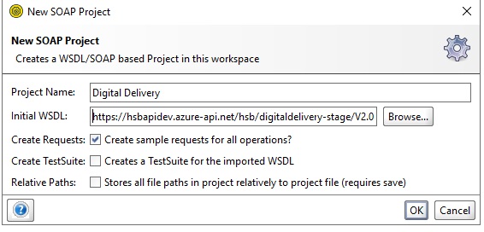
Click on request after successful project creation. Replace service url and sample request
Below attachment for quote request and response.
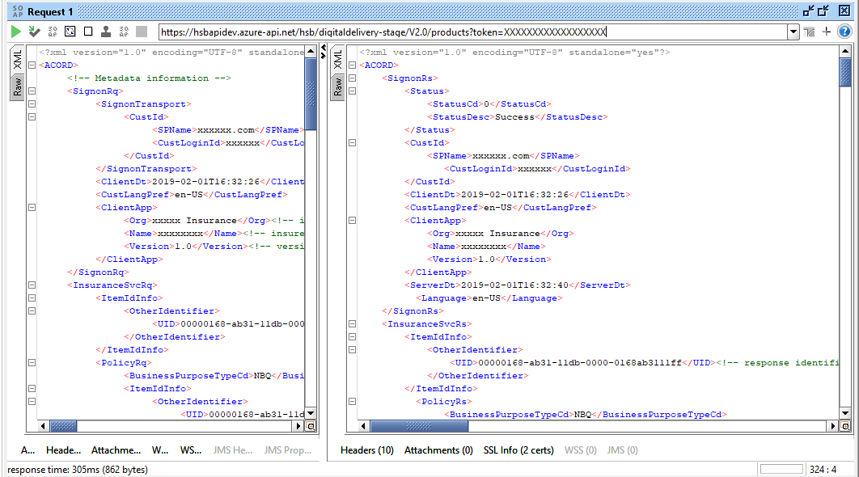

Below attachment for Bind request and response.
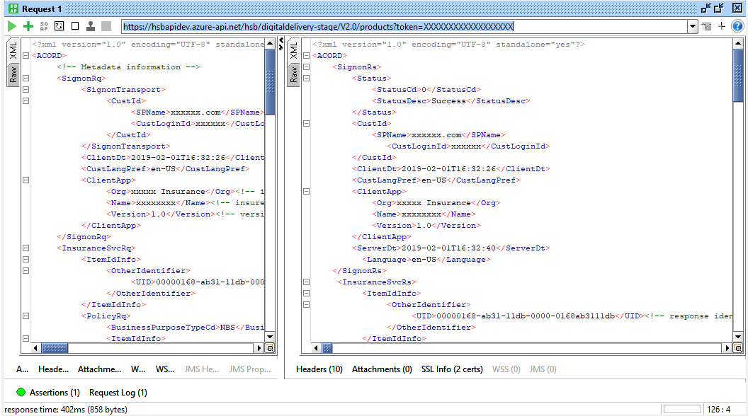
Below attachment for display Request and Response with Forms Data.
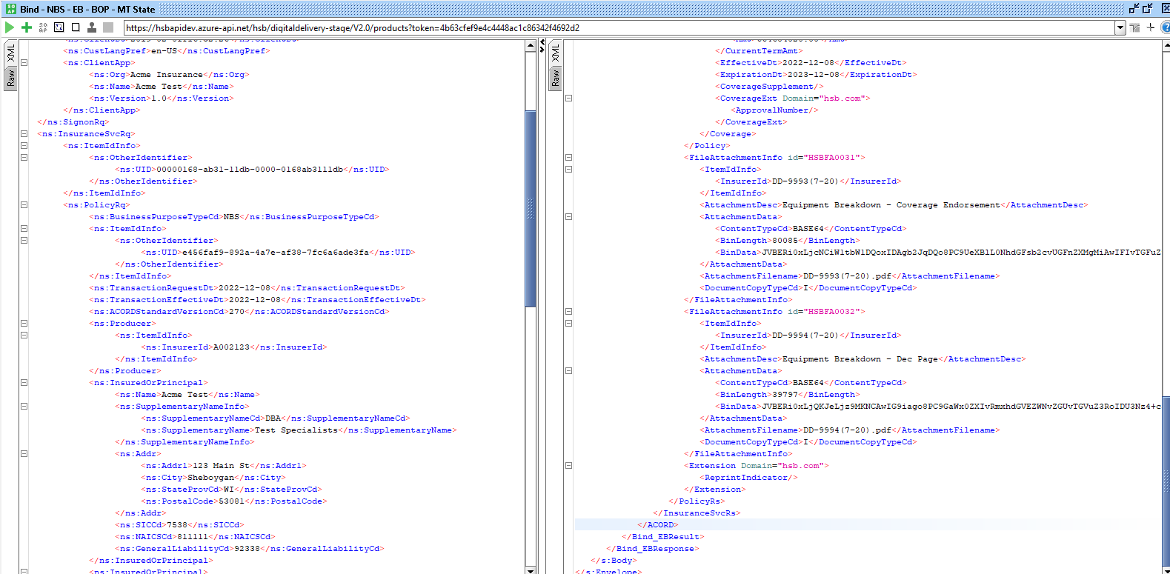

Below attachment for cancellation request and response.
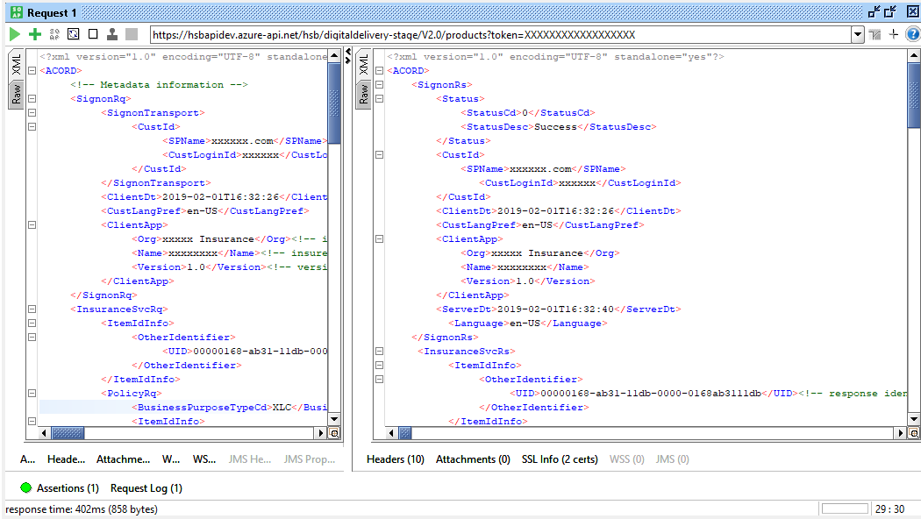

How to Test Using Developer Portal

9.1 Instruction on using the UID in the request

Follow below steps & instructions –
Step 1 - Open Developer portal https://developer.hsbfrontdoor.com/signin in any browser.
Step 2- Login using the credentials.
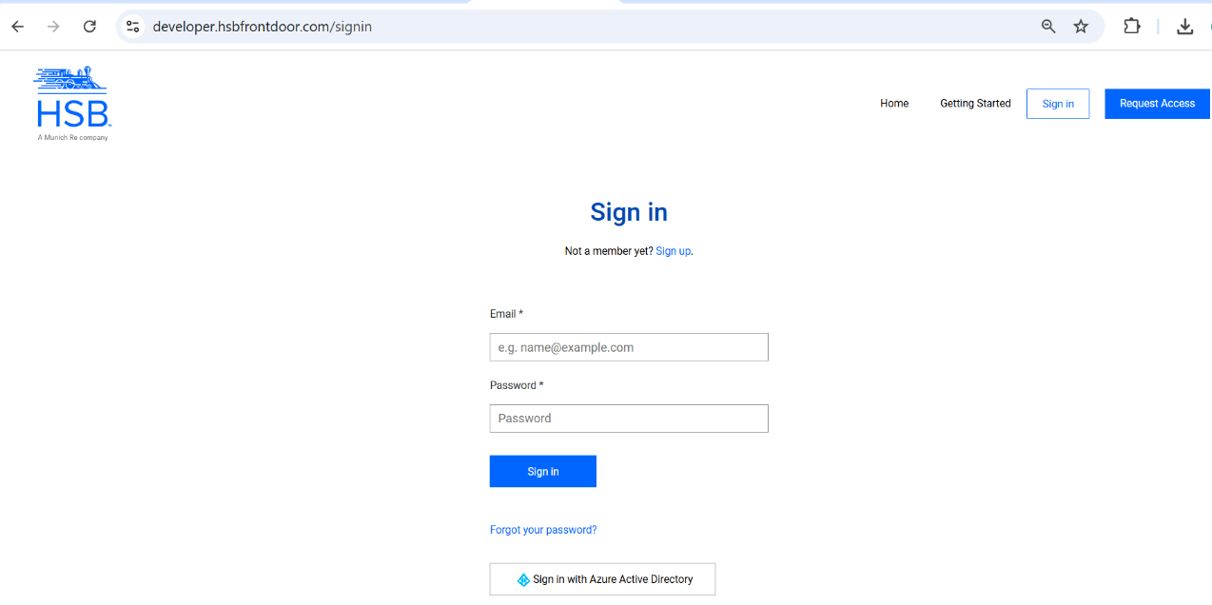

After log in you could see the Home page. Home page presents multiple options to Select Products, API lists, technical specifications on multiple products offered by HSB and ability to update the Profile.
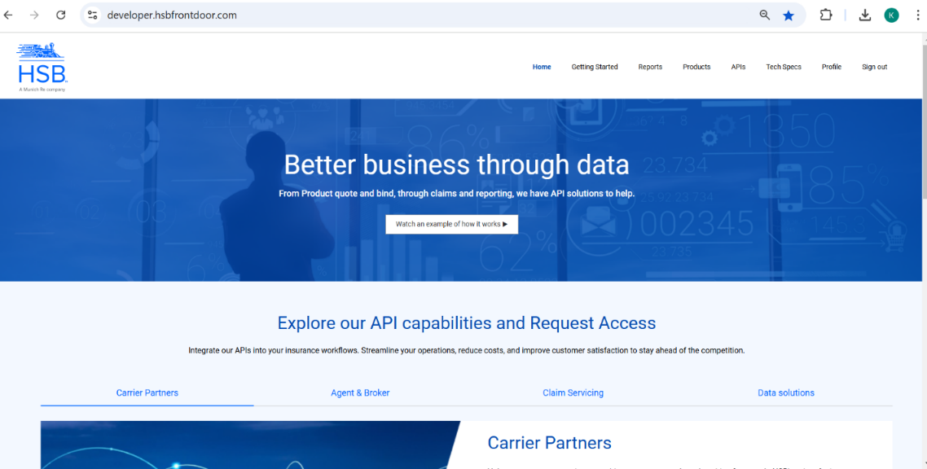

Step 3 – Click on the APIs tab on the top right corner.
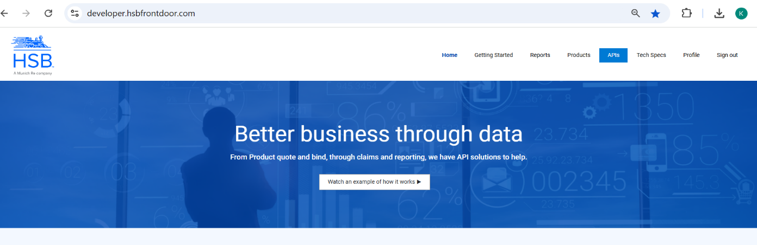

After clicking APIs, User will see below screen, where all APIs are listed along with its description.
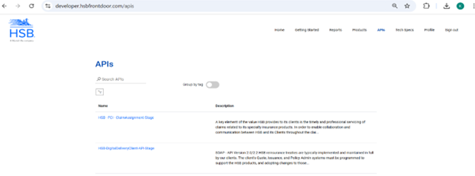

Step 4 – Click on HSB-DigitalDeliveryClient-API-Stage link from API list to see list of Operations and details.
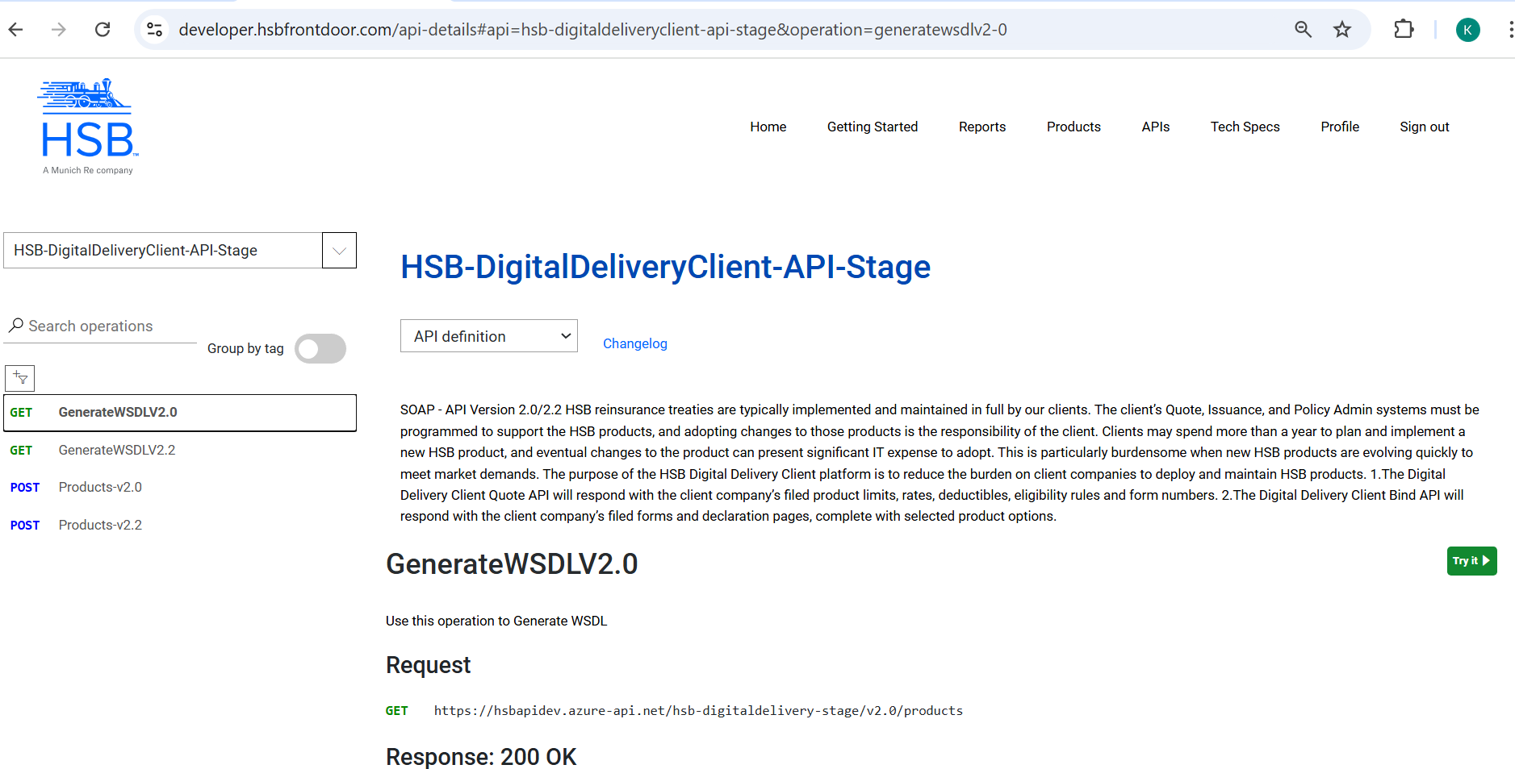

Step 5 – Click Products-v2.0 option from API list and click on Try It button to execute & test SOAP service.
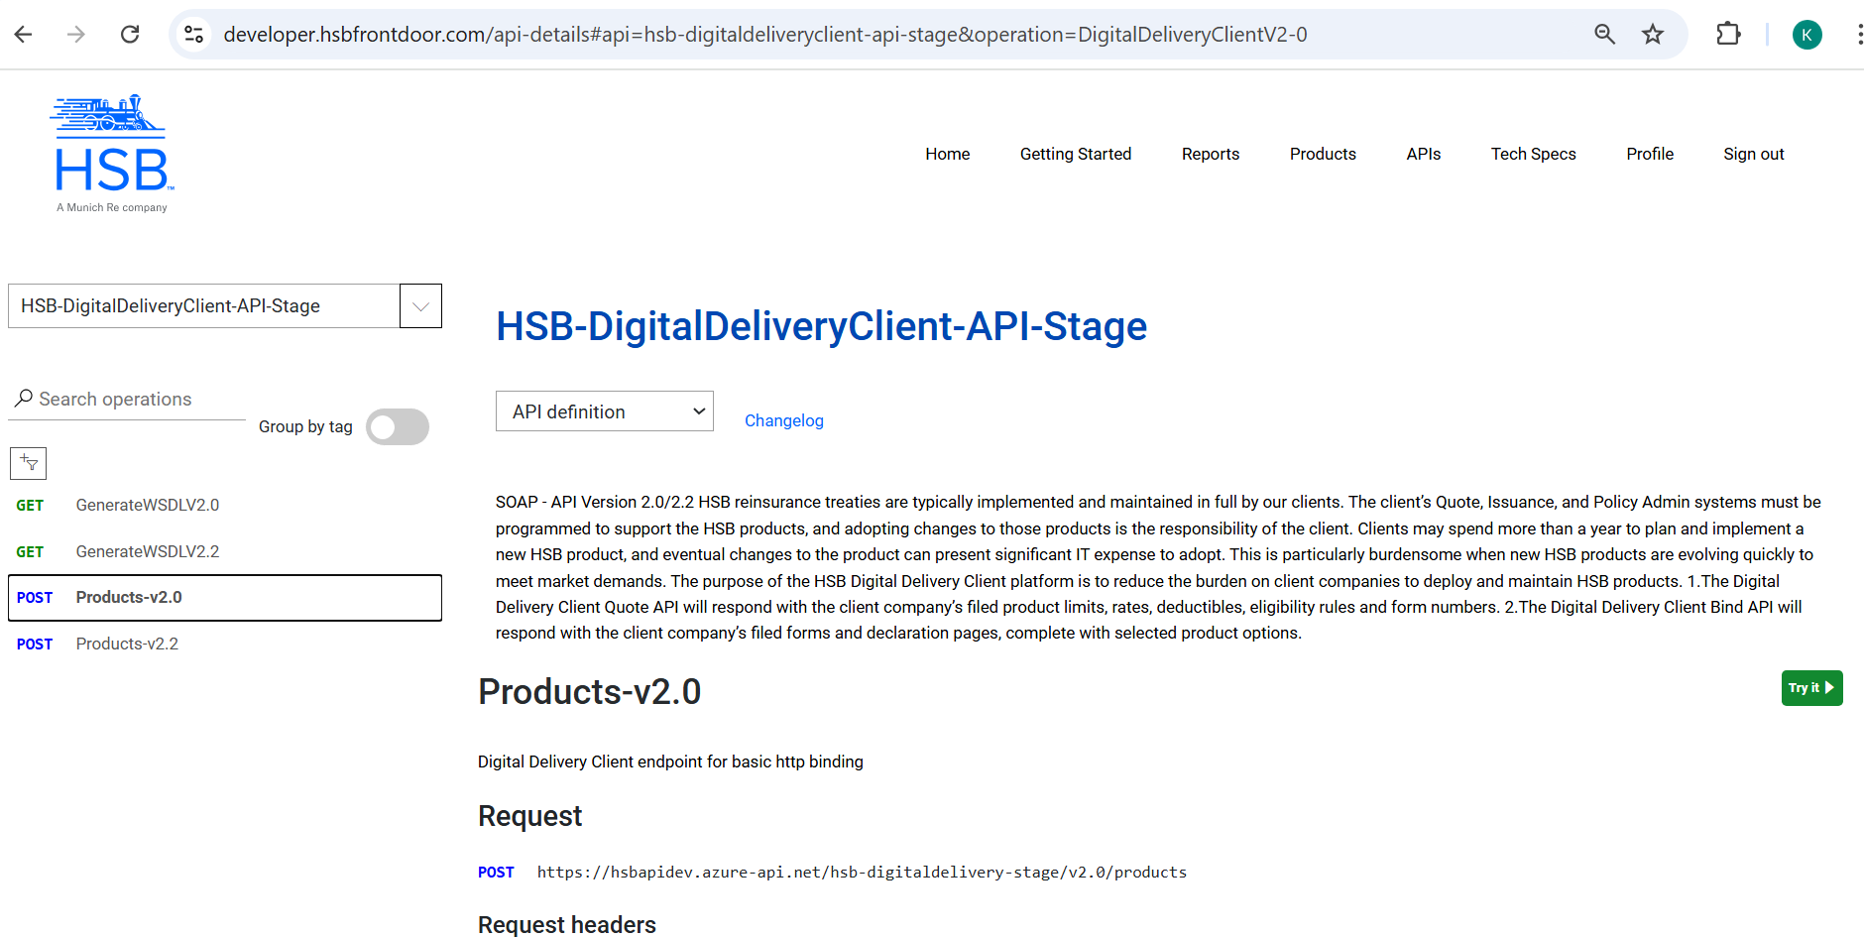
Step 6 - Once you click on Try It button below pop-up screen will appear, where user can test SOAP service. 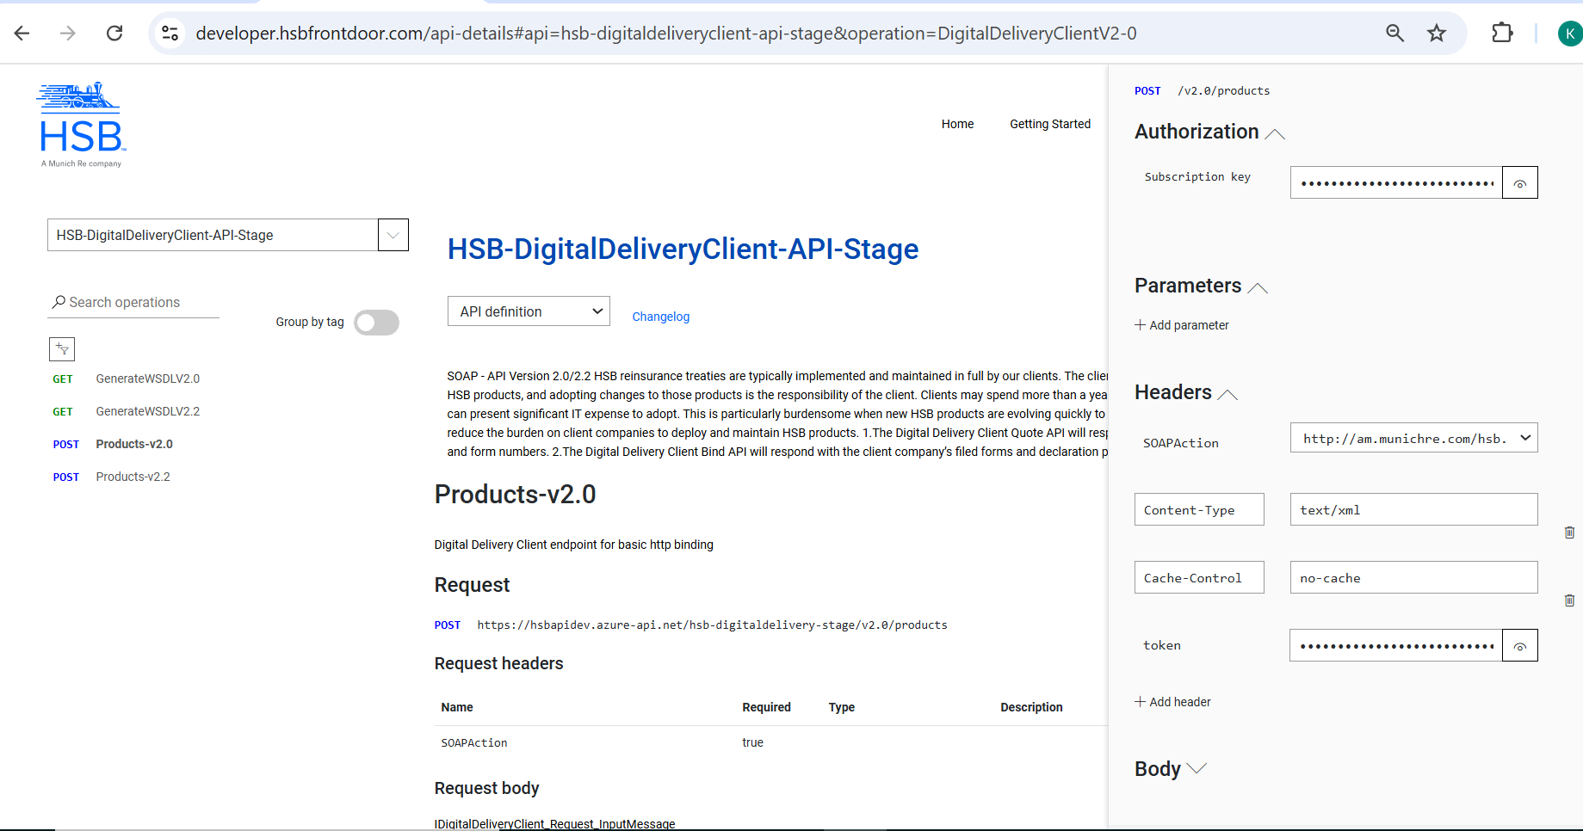
** You can change SOAPAction header value to test other products with Quote and Bind. Default is Equipment Breakdown with Quote.

Test EB (Equipment Breakdown) Product
To test EB product first, take sample Quote & Bind request from this 8.1 Sample Request section.
For EB Quote (Quote_EB)
Authorization
Token : xxxxxxxxxxxxxxxxxxxxxx
Headers
- Content-Type: text/xml;
- SOAPAction : http://am.munichre.com/hsb.services/1.0/IManagedProduct/Quote_EB
- Cache-Control : no-cache
- Token: xxxxxxxxxxxxxxxxxxxxxx

Body Select Request format as Raw from option.
- Put Sample request body in xml format under text box area.
- Make sure to change the UID (second UID) to a different number, but not changing the format of the UID, please refer the document for more details.
- 9.1 Instruction on using the UID in the request
- Please see below -
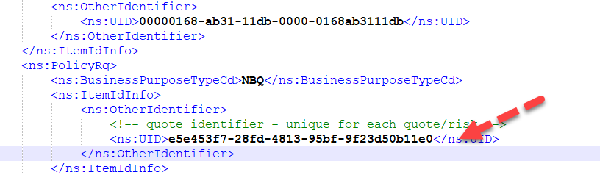

HTTP Request –
Do not change anything here. Keep default as HTTP
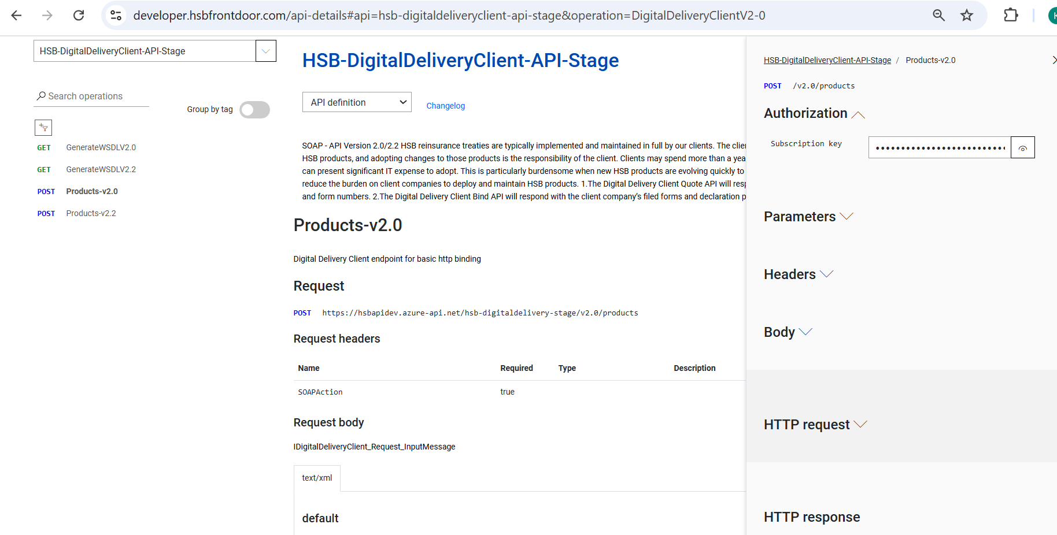
Step 7 : Click on Send button. After clicking on Send button you will get response 200 OK as status code in Success scenario
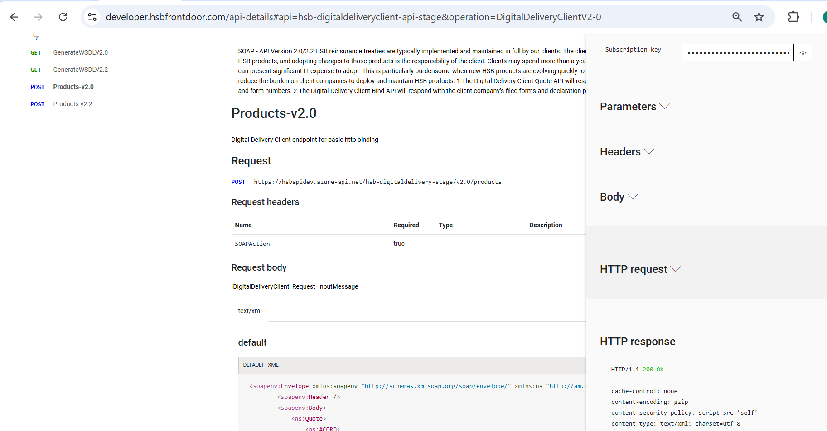

For EB Bind (Bind_EB)
Authorization
Token : xxxxxxxxxxxxxxxxxxxxxx
Headers
- Content-Type: text/xml;
- SOAPAction : http://am.munichre.com/hsb.services/1.0/IManagedProduct/Bind_EB
- Cache-Control : no-cache
- Token: xxxxxxxxxxxxxxxxxxxxxx
Body Select Request format as Raw from option.
- Put Sample request body in xml format under text box.
- Make sure to use the same UID (updated in the Quote request above) in the Bind request. Second UID ties the Quote to Bind request. Please refer the document for better understanding.
- 9.1 Instruction on using the UID in the request

HTTP Request – Do not change anything here. Keep default as HTTP
Step 7 : Click on Send button.
After clicking on Send button you will get response 200 OK as status code in Success scenario

Document Revision History

Version | Date | Updated By | Revision Description
1.0 | 07-Apr-2022 | Shwetav Pandit | Initial Version
2.0 | 22-Nov-2022 | Shwetav Pandit | Updated
3.0 | 19-June-2023 | Shwetav Pandit | Updated
4.0 | 24-Aug-2023 | Ritik Rahangdale | Update w.r.t. mandatory nodes and error messages
5.0 | 09-Nov-2023 | Ritik Rahangdale | Update w.r.t mandatory nodes
7.0 | 01-May-2024 | Shwetav Pandit | Added two message codes - HSBERR000006 and HSBERR000051  Need to check the Transaction request date on the REI, the TransactionRequestDt cannot be greater than X days from the TransactionEffectiveDt of the matching XLC transaction. X is the number of days in which cancelled policy can be reinstated.  Example - X = 3 | XLC - Transaction effective date = 4/18/2024 | REI Transaction request date = 4/21/2024, then Error. HSBERR000006 - Cancelled Policy cannot be reinstated.  ==================================================  Transaction = PCQ + Coverage code = EQPBK then,  Do the class code validation and Minimum Threshold validation but if the validation fails treat this as successful transaction but send the MsgStatusCd = SuccessWithInfo and ExtendedStatusCd =VerifyDataValue and ExtendedStatusDesc = HSBERR0000051 : Policy may be ineligible for renewal due to class code or TIV rules
8.0 | 12-Nov-2024 | Fran Zygmont | Added columns in Quote and Bind Requests to denote which fields are required from a reporting perspective (Bordereau / Inforce). Also added remediation steps for the Exception Handling and Recovery - Section 7.
9.0 | 09-Dec-2024 | Kushal Sakhare | Added HSB API Developer section details

